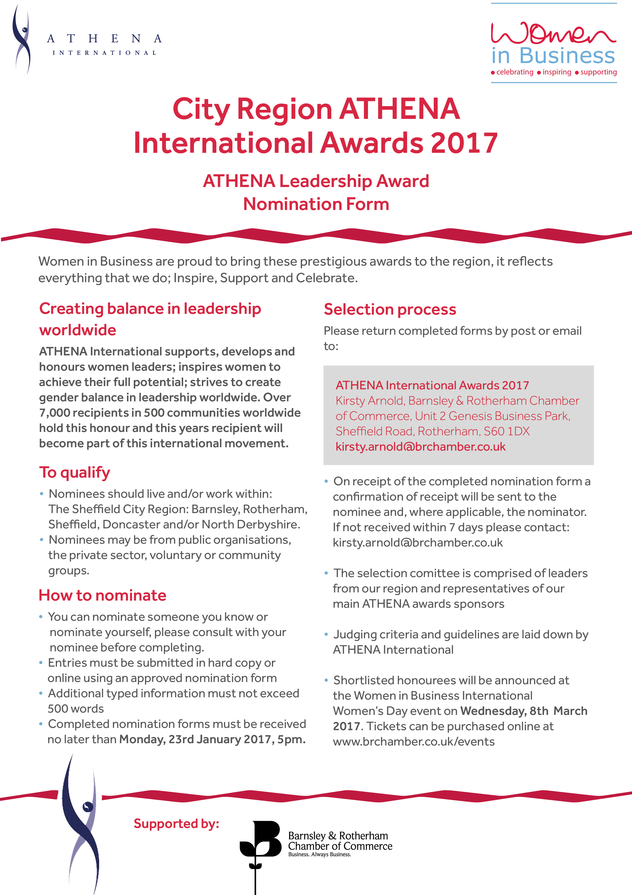

2017 Nomination Form

ATHENA LEADERSHIP AWARD
Nominee

Name Title

Company/Organisation/Group (if applicable)

Address

Post Code

Phone Mobile

Email

Nominator (if not self nominated)

Name Title

Company/Organisation/Group (if applicable)

Address

Post Code

Phone Mobile

Email

It is important to provide, in each section, specific examples of significant, measurable contributions that the nominee has made, which resulted in exceptional impact on their company/organisation/ group, or the lives of people in the City Region. Be as specific as possible with dates, positions held etc. Please use additional sheets as required.

Assists women in reaching their full leadership potential
Provide specific examples of how the nominee has demonstrated support for the advancement and leadership development of women. (500 Words)

2017 Nomination Form

Business/Professional Achievements
Show special recognitions, examples of projects and achievements that demonstrates the values of ATHENA in a professional/business capacity. (500 words)

Community Support
Show specific examples of where the nominee has demonstrated leadership roles and/or support within the community. State how the contributions have benefited the community. (500 words)

2017 Nomination Form

Additional information relevant to criteria
If appropriate, discuss briefly any additional factors you feel are important for consideration, such as personal triumphs, unpaid activities, voluntary work etc. (500 words)

Thank you for your interest and support for the ATHENA Leadership model. Good luck with your nomination.

Supporting, developing and honouring women leaders
Inspiring women to achieve their full potential
Creating balance in leadership worldwide

