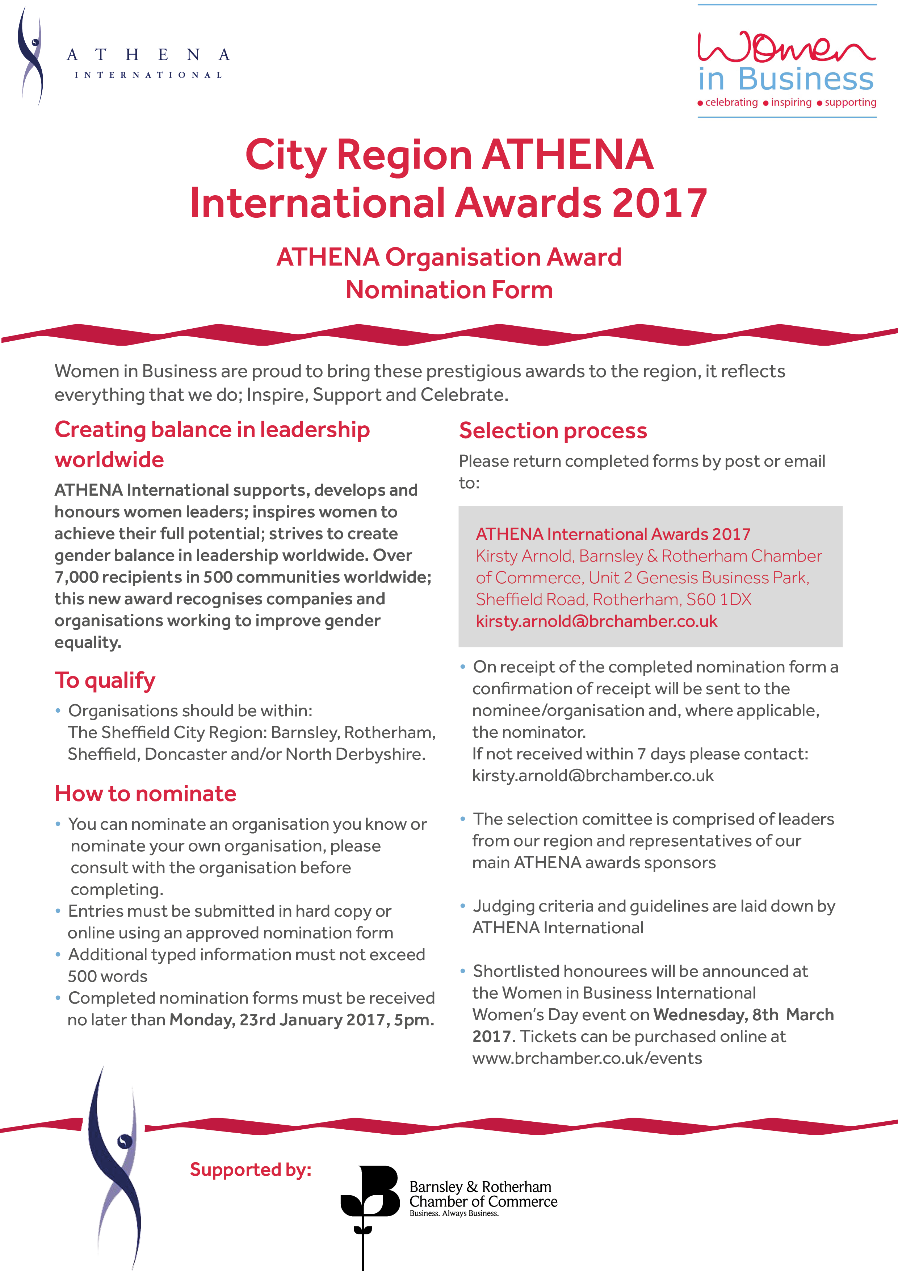

2017 Nomination Form

ATHENA ORGANISATION AWARD
Organisation details

Contact Name Title

Company/Organisation/Group (if applicable)

Address

Post Code

Phone Mobile

Email

Nominator (if not self nominated)

Name Title

Company/Organisation/Group (if applicable)

Address

Post Code

Phone Mobile

Email

It is important to provide, in each section, specific examples of significant, measurable contributions that the nominee has made, which resulted in exceptional impact on their company/organisation/ group, or the lives of people in the City Region. Be as specific as possible with dates, positions held etc. Please use additional sheets as required.

Culture of Equality and Diversity
Demonstrate how the culture of your organisation embeds equality and diversity into its business planning and operating practices. (500 Words)

- Nomination Form

Achieving full leadership potential
Provide examples of women in your organisation who have or are on the path to achieving their full leadership potential due to your organisational culture. (500 words)

Culture impact and impact on communities
Demonstrate and provide examples of how your culture is impacting and benefiting women and girls and the communities you work within. (500 words)

- Nomination Form

Demonstrate diversity and gender balance
Demonstrate how your leaders are role models and take ownership of the diversity/gender balance agenda. (500 words)

Additional information relevant to criteria
If appropriate, discuss briefly any additional factors you feel are important for consideration, such as personal triumphs, unpaid activities, voluntary work etc. (500 words)

Thank you for your interest and support for the ATHENA Leadership model. Good luck with
your nomination.
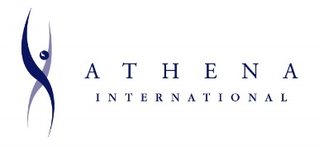
Supporting, developing and honouring women leaders
Inspiring women to achieve their full potential
Creating balance in leadership worldwide

